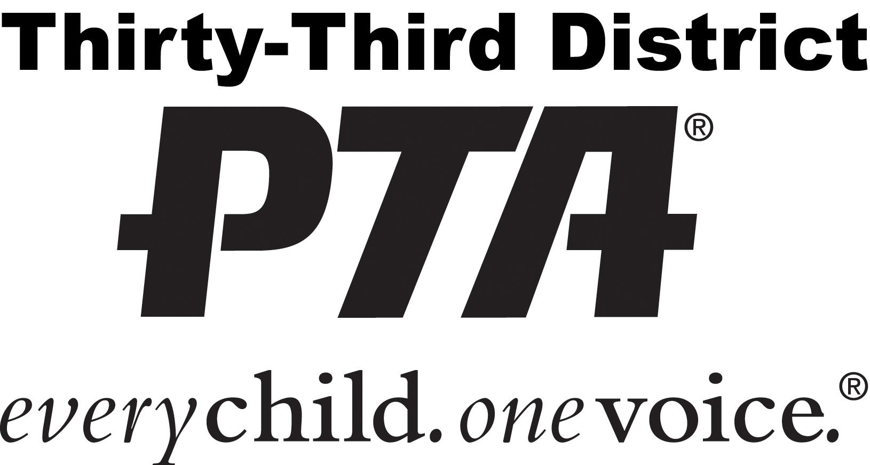

Annual Fall Association Meeting and
Officers Training Workshops
Make this year a HUGE SUCCESS with training!

📍 West High School, 20401 Victor Street, Torrance, CA 90503

⌚ Saturday, October 12, 2019
9:00 a.m. – 2:30 p.m.
8:00 a.m.: Check-in, light breakfast, and registration
9:00 a.m.: Association Meeting – attendance strongly encouraged; please bring your membership card.
9:30 a.m. Workshops begin

Registration Cost
- Before Sept. 23: $15.00 per person (includes workshops and lunch)
- Sept. 24 thru Sept. 27: $25.00 per person (includes workshop and lunch)
- Walk-In: $25.00 per person. Walk-in registration will be allowed but handouts and lunch cannot be guaranteed.
- There is no charge for attending just the Association Meeting but you must complete the registration form.

Payments & Reservations Due
- Units: Reservations to council by __________________________
- Councils: Remit forms and payments by 9/23/2019 at the Executive Board Meeting

Workshop & Lunch Selections
- Indicate your lunch and workshop options below and return form with payment.
One form per person
- - - - - - - - - - - - - - - - - - - - - - - - - - - - - - - - - - - - - - - - - - - - - - - - - - - - - - - - - - - - - - - - - - - - - - - - - - - -
Annual Fall Association Meeting and Officers Training Workshops Registration Form
Fill out the form below for each person attending. Indicate your lunch option and workshop selections below. Workshops are described on the next page.
Name: |  | PTA position:
PTA unit: |  | PTA council:
Email: |  | Phone:
Lunch: | Regular Vegetarian (check or circle one) | Meeting Only: | _______ (check here)
Session 1 Workshop: |  | Session 2 Workshop:
Session 3 Workshop: |  | Amount Paid: | _

WORKSHOP CHOICES (select one workshop per session)
** Spanish translation available only in these workshops

Session 1: 9:45 a.m. – 11:00 a.m. | Session 2: 11:15 a.m. – 12:30 p.m. | Session 3: 1:15 p.m. – 2:30 p.m.
President **  Valuable information and resources to help presidents and provide the tools to succeed. | President and Leadership Round Table **  Informal question and answer session regarding leadership and your role as a president. | Conflict Resolution  Learn how use leadership tools to manage conflict in your unit.
Parliamentarian  You have been appointed, now what? Learn the duties of parliamentarian including your role at meetings, how to help your president, and the basics of nominations and elections. | Submitting Bylaws  Understand the procedure for reviewing, updating, and submitting bylaws. Learn how units can use e-bylaws to revise and update their bylaws.  BRING A COPY OF YOUR BYLAWS! We will go through them step-by-step during the workshop. | Nominating Committee/Elections  Learn how to create Nominating Committees, their responsibilities, and the PTA election process.
Education/Parent Involvement  Learn what’s going on in our community, school, and PTAs, and share your ideas! | Reflections  Learn how to implement the Reflections art program, facilitate student involvement, and how to submit artwork. A great opportunity to ask questions early on. | Diversity and Inclusion  Discussion on supporting multicultural membership growth, how to engage with underrepresented groups, and determine key strategies for specific groups.
Beginning Finance – Part 1 **  This is a two-session workshop intended for financial officers. | Beginning Financial – Part 2 **  This is part 2 of the Financial workshop. | PTA EZ  PTA EZ is a fully web-based PTA fund management solution created by PTA leaders. It offers a simple way to account for your funds and other organizational requirements, along with a multitude of other features to help make your role in PTA even easier!
Sign up for both sessions.
Topics include: banking, budgets, money handling, financial reports, and your role on your financial team.
Advanced Finance  This workshop is for council financial officers and experienced unit officers. Topics include: amending budgets, correcting financial reports, and reviewing financial practices. | Auditor  Learn how to conduct an audit. A checklist and step-by-step procedures will be presented. | Health  Learn about the health issues affecting our children and what PTA can do to help.
Membership – Basics **  PTA membership is important! Learn the who, what, and why of PTA membership. Learn ideas on how to create and launch a successful membership campaign. | Membership – Beyond Basics **  Membership is all about gaining and retaining members – share best practices, questions and answers, etc. | Historian  Learn the responsibilities of the historian, including how and why we track volunteer hours and ideas for showcasing your PTA’s history.
Recording Secretary Part 1**  This is a two-session workshop intended for newbies. We’ll cover what you need to know and what to do as secretary. You’ll get lots of guidance on how to make things like motions and record-keeping easier! | Recording Secretary Part 2 **  Basics for newbies continued: We’ll continue to cover what you need to know and what to do as secretary as well as providing a forum for Q&A. | Recording Secretary - Advanced **  Dive into some of the challenges secretaries can face as well as refresh your knowledge of secretary basics. This is an ideal workshop for returning secretaries and a forum for Q&A.
Advocacy & Sacramento Safari  Why advocate? Learn how to advocate in your school district, the community and beyond. | Communications 101  We’ll cover best practices and tools for communicating with your team, parents, and partners. | Programs Round Table  Discussion on how to prepare an  effective schedule of PTA programs.

