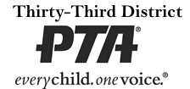
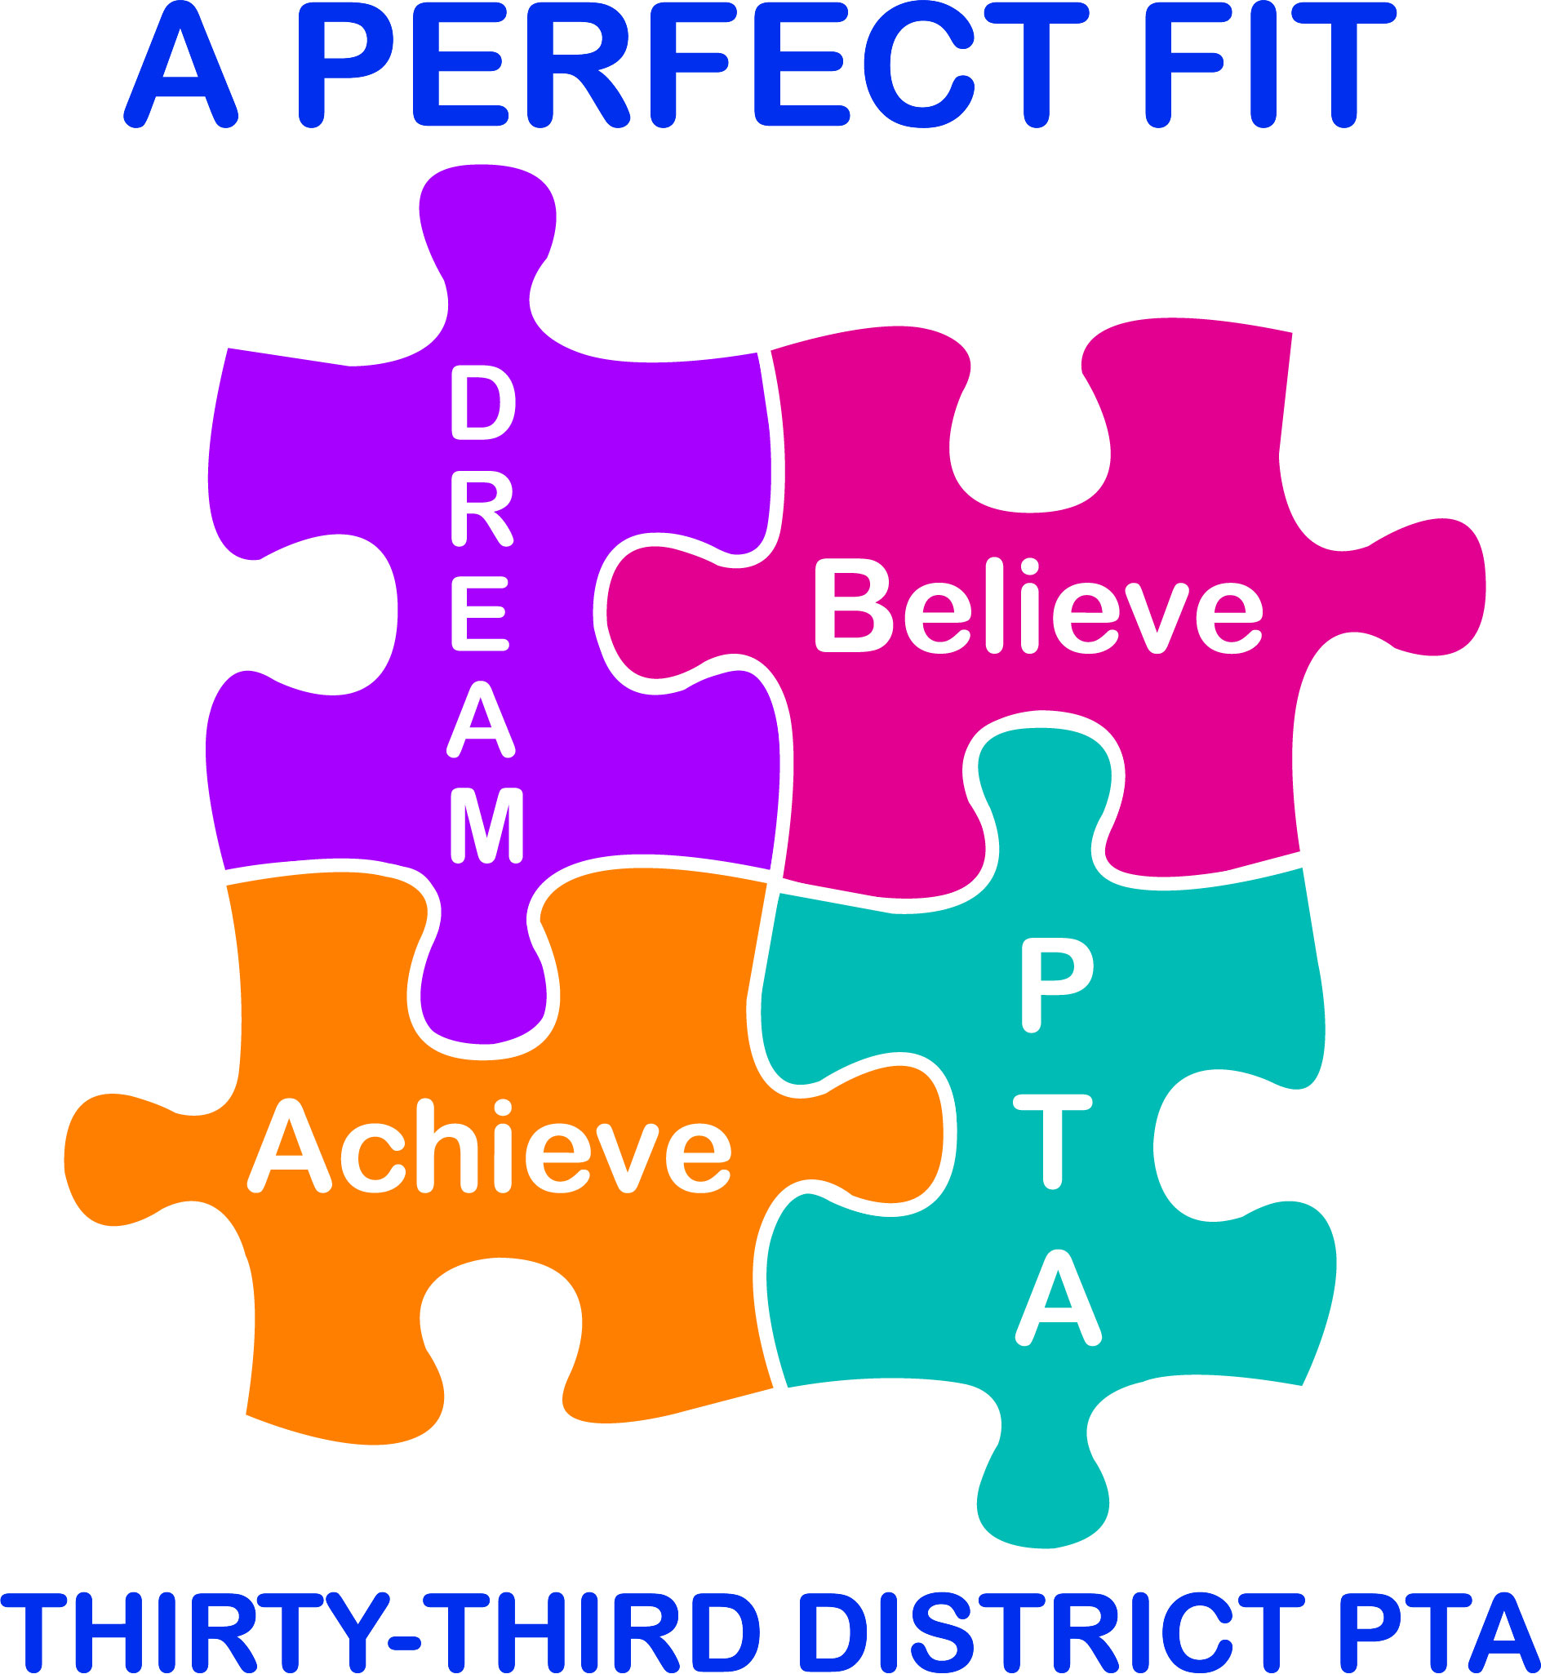
Spring Awards & Association Meeting
When: Thursday, April 23, 2020
8:30 a.m. Registration
9:00 a.m. Breakfast
9:30 a.m. Program

Where: The Grand, Long Beach Event Center
4101 E. Willow Street
Long Beach, California 90815

Cost: $30.00 per person ($40.00 after April 8, 2020)
Buffet Breakfast Included

AWARDS, AWARDS, AWARDS!

The Spring Awards & Association Meeting is one of our three district association meetings and your attendance is very important. Be sure to bring your membership card so that you can vote. Awards being presented may include those for Exhibit displays, Honorary Service Awards, Membership, and District Recognition.

Join us as we recognize all of the great things our units have accomplished!

Council Due Date: March 3, 2020 District Due Date: April 8, 2020
(Units must register through their council by Council Due date)
-------------------------------------------------------------------------------------------------------------------------------

Spring Awards & Association Meeting – Thursday, April 23, 2020

Units: Send reservations to your council by the council due date.
One form per attendee please.

Cost — $30.00 (40.00 after April 8, 2020)—checks payable to your council

Name Phone
PTA Unit PTA Council

Council Treasurer: Make your check payable to Thirty-Third District PTA and mail to:
Thirty-Third District PTA, P.O. Box 1235, Lakewood, CA 90714
Check and RSVPs must be in the district office no later than April 8, 2020.

